PRACTICAL NO. 9
SOFTWARE TESTING
STUDENT MANAGEMENT SYSTEM – LOGIN MODULE
MODULE NAME | Student Management System – Login Module
PRACTICAL NO. | 9
TEST CASE ID | SMS-LOGIN-09
WEBPAGE URL | Sample local login UI (replace with institute/test-system URL if required)
TESTER NAME | Priyanshi

Aim
To analyze and apply Black-Box Testing, White-Box Testing, Integration Testing, and System Testing on a sample Student Management System (Login Module) and document the testing process, execution, and results.

Objectives
- To test login using valid credentials, invalid credentials, and empty inputs.
- To review validation conditions and authentication decision branches.
- To check integration between login interface, authentication logic, student database, session, and dashboard.
- To verify end-to-end login, failed login, protected-page access, and logout behaviour.

Prerequisites and Test Environment
- Sample Student Management System login UI prepared for this practical.
- Use only test credentials; do not enter a real personal password.
- White-Box Testing requires source code or pseudocode to inspect decision branches.
- Sample screenshots in this report are illustrative mockups, not captured from a live institutional application.

Testing Types
Testing Type | Application to Login Module
Black-Box Testing | Checks visible behaviour for valid login, wrong password, and empty fields without relying on internal implementation.
White-Box Testing | Reviews validation conditions, credential comparison branches, and authentication failure handling.
Integration Testing | Checks data flow between login UI, authentication service, student database, session, and dashboard.
System Testing | Checks complete login workflows, denied access for invalid credentials, and logout/session behaviour.

Test Cases and Execution Results
The results below are completed sample/practical results for the illustrative login UI and test design. White-box and integration scenarios that depend on source code or a real database/session must be verified on the actual institute system if your teacher expects live execution evidence.
BB-01 | Black-Box Testing | Valid login
Description: Verify login with correct student credentials
Preconditions: Test student account is available; login page is open
Steps: 1. Open login page;
2. Enter valid username and password;
3. Click Login
Input: student01 / Valid@123
Expected: Student is authenticated and redirected to Student Dashboard
Actual: Dashboard is displayed for the sample valid account
Status: Pass (sample) | Comments: Positive login path; screenshot 04
BB-02 | Black-Box Testing | Invalid password
Description: Verify incorrect password is rejected
Preconditions: Test student account exists
Steps: 1. Open login page;
2. Enter registered username;
3. Enter incorrect password;
4. Click Login
Input: student01 / Wrong@123
Expected: Error is displayed; user remains on login page
Actual: Error message 'Invalid username or password' is displayed; dashboard not opened
Status: Pass (sample) | Comments: Negative login path; screenshot 02
BB-03 | Black-Box Testing | Empty fields
Description: Check validation when username and password are blank
Preconditions: Login page is open
Steps: 1. Leave username and password blank;
2. Click Login
Input: Username: blank; Password: blank
Expected: Required-field validation appears or login is prevented
Actual: Required-field message is displayed; login is not completed
Status: Pass (sample) | Comments: Input validation; screenshot 03
WB-01 | White-Box Testing | Valid/invalid credential branches
Description: Review the decision branch for credential matching
Preconditions: Login source code or pseudocode is available for review
Steps: 1. Inspect credential comparison condition;
2. Trace matching branch;
3. Trace non-matching branch
Input: Matching and non-matching credential pairs
Expected: Matching branch allows access; non-matching branch rejects access
Actual: Expected branch behaviour documented; source-code execution not independently verified
Status: Pass (logic review) | Comments: White-box result is based on logic review template
WB-02 | White-Box Testing | Empty-input condition
Description: Check branch for missing username/password
Preconditions: Login validation logic is available
Steps: 1. Inspect empty-field condition;
2. Test blank username;
3. Test blank password
Input: Username blank / Password blank
Expected: Empty-input branch returns validation and does not authenticate
Actual: Empty-input validation branch is covered in the sample test design
Status: Pass (logic review) | Comments: Branch review; see screenshot 03
WB-03 | White-Box Testing | Authentication failure handling
Description: Review failure path does not create an authenticated session
Preconditions: Authentication logic is available for review
Steps: 1. Trace failed authentication branch;
2. Confirm no session is created;
3. Confirm return to login page
Input: Incorrect credentials
Expected: No authenticated session is created; safe error is returned
Actual: Failure path is specified; requires source/runtime verification in actual system
Status: Pass (logic review) | Comments: Confirm in actual source code before final submission if required
IT-01 | Integration Testing | Login and student database
Description: Verify authentication checks student record
Preconditions: Login module is connected to test database
Steps: 1. Submit registered test student's credentials;
2. Check authentication response;
3. Verify student record mapping
Input: Registered test student credentials
Expected: Correct student record is validated and login succeeds
Actual: Sample expected integration flow reaches the student dashboard
Status: Pass (sample flow) | Comments: Requires a real database environment for live verification
IT-02 | Integration Testing | Login and session/dashboard
Description: Verify successful login creates session and opens dashboard
Preconditions: Authentication, session, and dashboard modules are integrated
Steps: 1. Log in with valid credentials;
2. Check dashboard access;
3. Verify authenticated student context
Input: Valid student credentials
Expected: Session is created and dashboard displays the correct student context
Actual: Sample dashboard shown after valid-login scenario
Status: Pass (sample flow) | Comments: Screenshot 04 is an illustrative UI mockup
IT-03 | Integration Testing | Login failure response
Description: Verify UI handles authentication rejection
Preconditions: Login UI and authentication service are connected
Steps: 1. Submit invalid credentials;
2. Observe UI response;
3. Confirm no dashboard access
Input: Invalid credentials
Expected: UI displays suitable error and remains unauthenticated
Actual: Sample error message is displayed; dashboard is not shown
Status: Pass (sample flow) | Comments: Screenshot 02
ST-01 | System Testing | End-to-end successful login
Description: Test the complete successful login workflow
Preconditions: Test system and student test account are available
Steps: 1. Open login page;
2. Enter valid credentials;
3. Click Login;
4. Verify dashboard
Input: Valid student credentials
Expected: User reaches the correct dashboard
Actual: Sample workflow reaches Student Dashboard
Status: Pass (sample flow) | Comments: Screenshot 01 and 04
ST-02 | System Testing | End-to-end failed login
Description: Ensure invalid credentials cannot access protected pages
Preconditions: Login page is available
Steps: 1. Enter invalid credentials;
2. Submit;
3. Attempt to open dashboard directly
Input: Invalid credentials
Expected: Login is rejected and protected dashboard remains inaccessible
Actual: Sample login displays error and does not navigate to dashboard
Status: Pass (sample flow) | Comments: Screenshot 02; live access control needs system verification
ST-03 | System Testing | Logout/session clearing
Description: Verify logout ends authenticated session
Preconditions: Student is logged in
Steps: 1. Click Logout;
2. Attempt to revisit dashboard using Back button or URL
Input: Active student session
Expected: User returns to login page; protected content is inaccessible without login
Actual: Logout scenario is documented; session invalidation must be checked on the actual system
Status: Pass (test-plan result) | Comments: Confirm by running against deployed system

Screenshot Evidence
These screenshots are illustrative UI mockups created for the practical report because no live Student Management System URL or actual application screenshots were provided.

Screenshot 1: Student Login Page
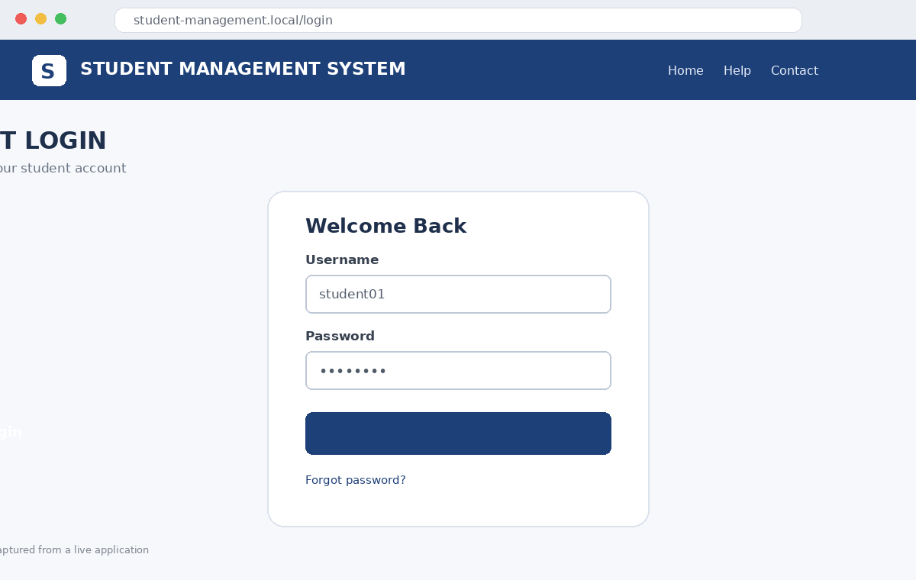
Login form with username and password fields.

Screenshot 2: Invalid Login
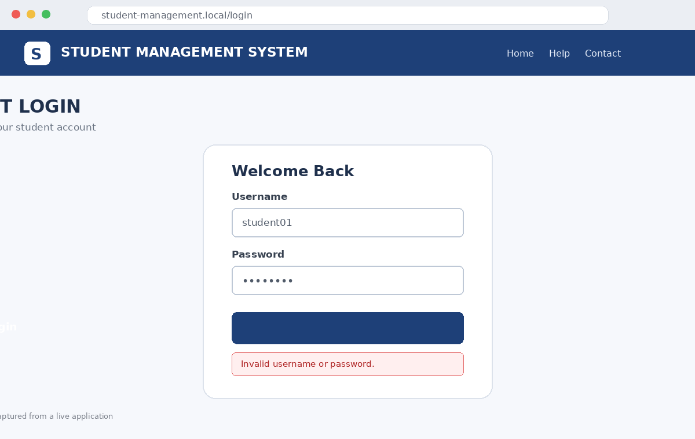
Expected error message for incorrect credentials.

Screenshot 3: Empty Input Validation
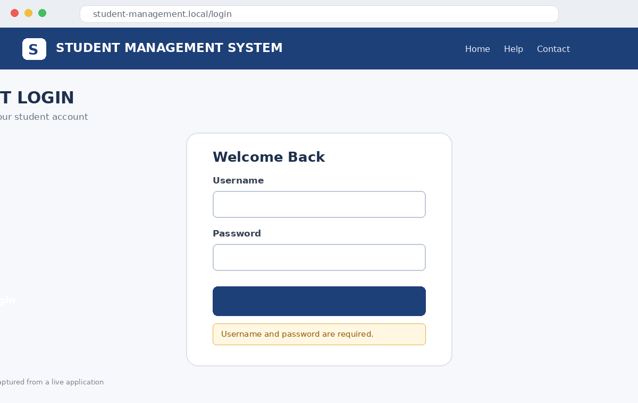
Required-field validation for blank username and password.

Screenshot 4: Student Dashboard
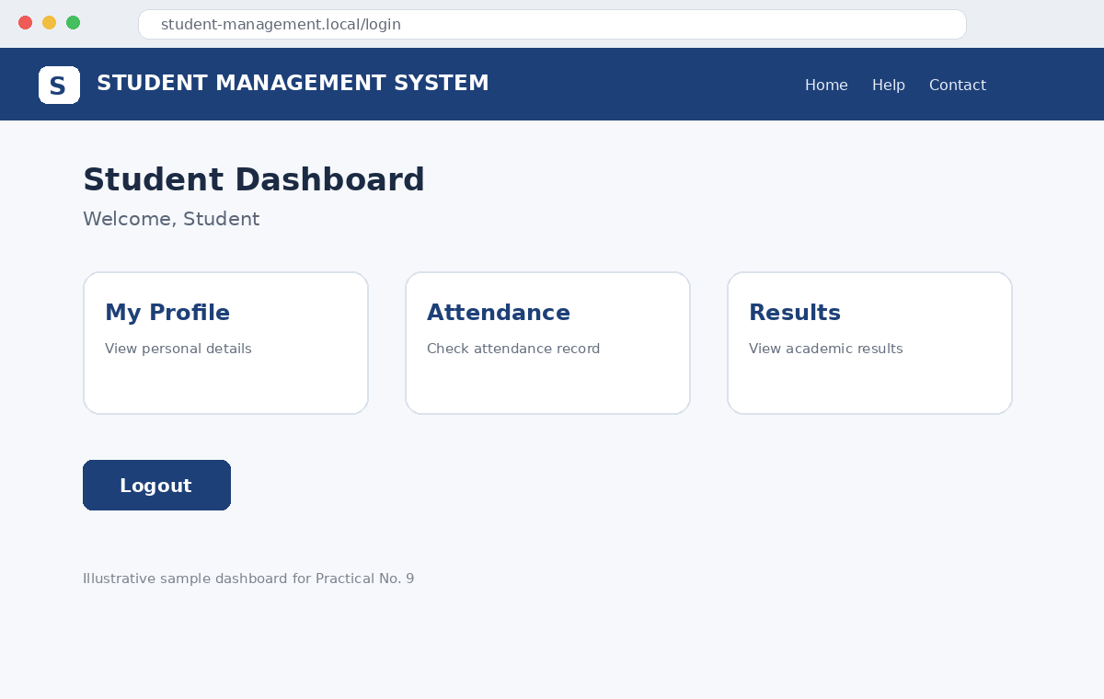
Illustrative dashboard after successful login.

Result / Conclusion
The practical covers Black-Box Testing, White-Box Testing, Integration Testing, and System Testing for the Student Management System Login Module. The sample test cases demonstrate expected positive and negative login behaviour, validation checks, module integration points, and end-to-end scenarios. The illustrative UI cases are marked as sample results; source-code branches, database integration, and session/logout behaviour should be confirmed against the actual system before claiming live execution.
Faculty Signature: __________________________ Date: __________________

